ONE AND ONLY BBQ 2023 HOLIDAY CATERING
BUFFET MENU(FOR INDIVIDUAL BOX LUNCHES ASK FOR THE HOLIDAY BOX LUNCH/DINNER MENU)
$15 Delivery Fee in Memphis Metro Area

Minimum 15 Guests Served as a Buffet
CHOOSE ONE OR BOTH MEATS (SAME PRICE)
Smoked Sliced Turkey Breast
Smoked Spiral Ham (Removed from the Bone)
Green Beans
Cornbread Stuffing
Dutch Crust Sweet Potato Casserole
Giblet Gravy
Cranberry Sauce
Hawaiian Dinner Rolls
ALL COMPLIMENTARY DISPOSABLES ARE STYROFOAM PLATES & CUPS, PLASTIC FORKS, KNIVES & SPOONS & PAPER NAPKINS UNLESS HARD CLEAR PLASTIC DISPOSABLES ARE REQUESTED WITH AN UPCHARGE OF $1 PER GUEST.

MINIMUM 15 Guests
15-49 Guests - $15.99 Per Person
50 -99 Guests - $15.50 Per Person
100 OR MORE Guests - $14.99 Per Person
Add Sweet Tea, Un-sweet Tea, Pink Lemonade, Ice, Cups, Lemon Slices
$1.50 Additional Per Person

Add Half & Half Millie’s House made Banana Pudding with Fresh Meringue & Fresh Baked Assorted Cookies
$2.00 Additional Per Person

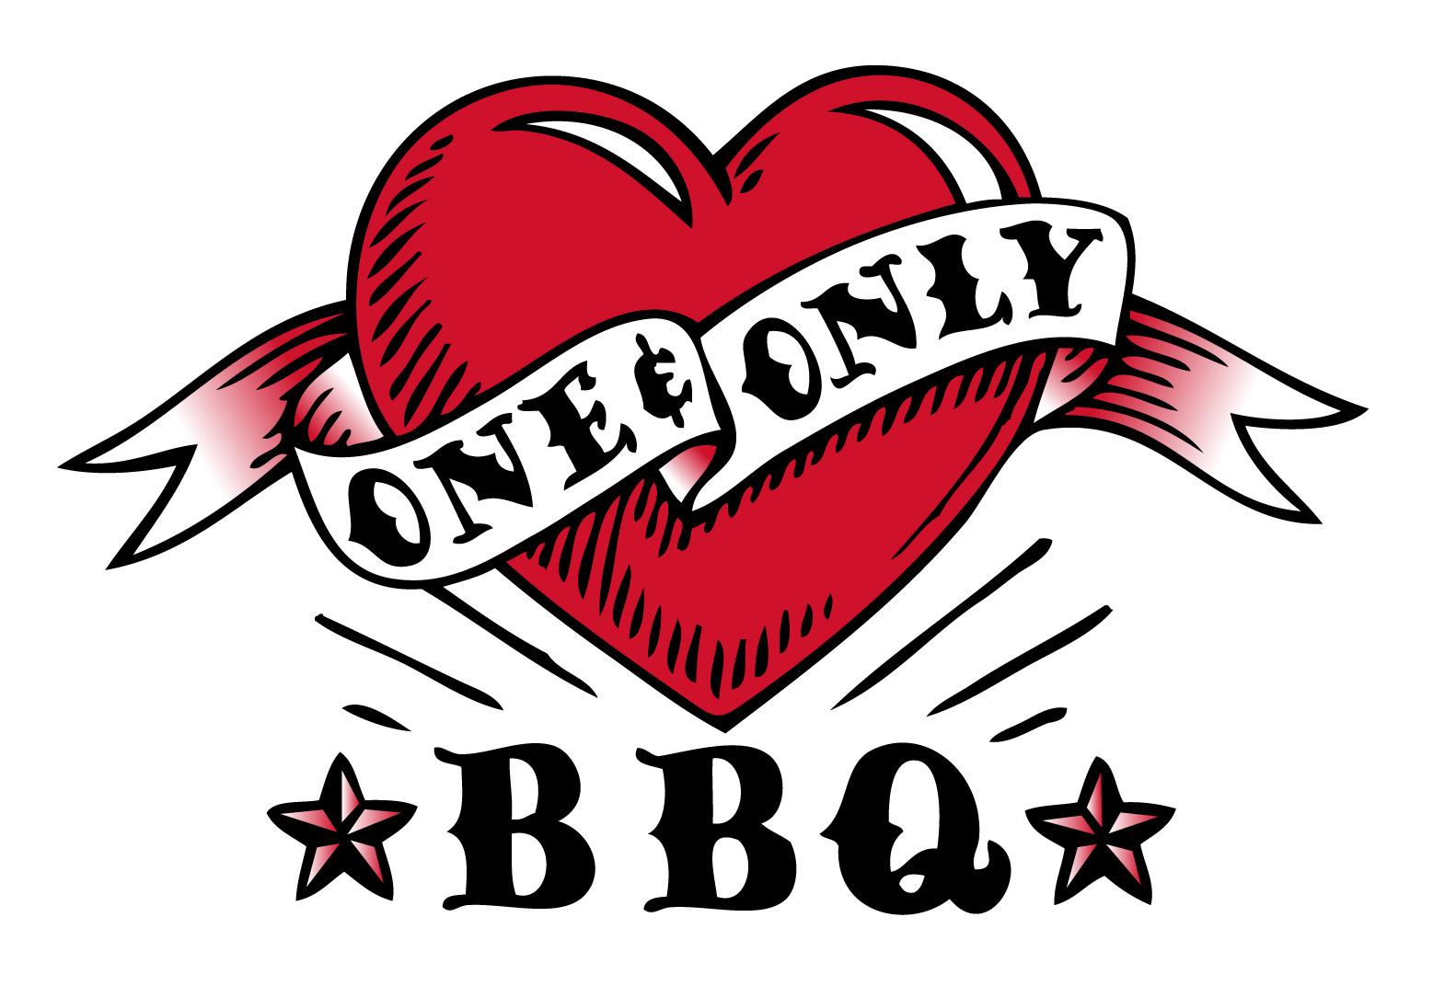

To Order Please Call
901-751-3615 (1779 Kirby Pkwy.)
901-275-8450 (Timber Creek at Germantown Road)
662-349-9981 (6575 Airways Blvd., Southaven)

